HAJU PAINTS SOLUTIONS

Mobile App Development Proposal

Executive Summary
HAJU Paints Solutions aims to revolutionize the paint industry in Kenya by developing a comprehensive digital platform that connects customers with high-quality paints and professional painting services. This proposal outlines the development of a mobile application ecosystem comprising a customer mobile app, painter registration portal, and admin management system.

1. Project Overview
Project Name: HAJU PAINTS SOLUTIONS APP
Project Duration: 3 months
Project Type: Mobile App Development with Web Admin Portal
Primary Objectives:
- Enable customers to purchase paints and book painting services remotely
- Create a platform for painters to register and manage their availability
- Implement seamless payment integration with M-Pesa
- Provide comprehensive customer support and feedback mechanisms
- Establish an efficient admin portal for business management

2. System Architecture
The HAJU Paints Solutions platform will consist of three main components:

2.1 Customer Mobile App (Angular Ionic)
- Cross-platform mobile application for iOS and Android
- User-friendly interface for paint selection and service booking
- Real-time notifications and order tracking
- Integrated payment gateway with M-Pesa

2.2 Admin Portal (Angular)
- Web-based administration dashboard
- User management and analytics
- Order processing and painter assignment
- Inventory management and reporting

2.3 Backend API System (Go)
- RESTful API architecture
- Database management with MySQL
- Third-party integrations (M-Pesa, Africastalking)
- Security and authentication protocols

3. Core Features

3.1 Customer Features
- Paint Catalog: Browse and purchase interior, exterior, and industrial paints
- Service Booking: Schedule professional painting services
- Color Consultation: Virtual color matching and recommendations
- Order Tracking: Real-time updates on paint delivery and service appointments
- Payment Integration: Secure M-Pesa payment processing
- Customer Support: Live chat, complaints, and feedback system
- Order History: Track past purchases and services

3.2 Painter Features
- Registration Portal: Professional painter onboarding
- Availability Management: Real-time status updates (available/engaged)
- Job Assignments: Receive and accept service requests
- Earnings Tracking: Monitor completed jobs and payments
- Profile Management: Update skills, certifications, and portfolio

3.3 Admin Features
- Dashboard Analytics: Sales, orders, and performance metrics
- User Management: Customer and painter account administration
- Inventory Control: Paint stock management and procurement
- Order Processing: Manage paint orders and service requests
- Payment Management: Track transactions and painter payments
- Reporting: Generate business intelligence reports

4. Technical Specifications

4.1 Frontend Technologies
- Customer Mobile App: Angular Ionic Framework
  - Cross-platform compatibility (iOS/Android)
  - Native device features access
  - Push notification support
- Admin Portal: Angular Framework
  - Responsive web design
  - Material Design components
  - Real-time data updates
  - Advanced filtering and search

4.2 Backend Technologies
- Server-Side: Go Programming Language
  - High-performance HTTP server
  - Concurrent request handling
  - RESTful API architecture
  - JWT authentication and authorization
- Database: MySQL
  - Relational database management
  - Data integrity and consistency
  - Optimized query performance
  - Backup and recovery protocols

4.3 Third-Party Integrations
- M-Pesa API: Payment processing and transaction management
- Africastalking SMS API: Automated notifications and alerts.
- Email Integration : Notification and alerts

5. System Flow Diagrams

5.1 Customer Order Flow
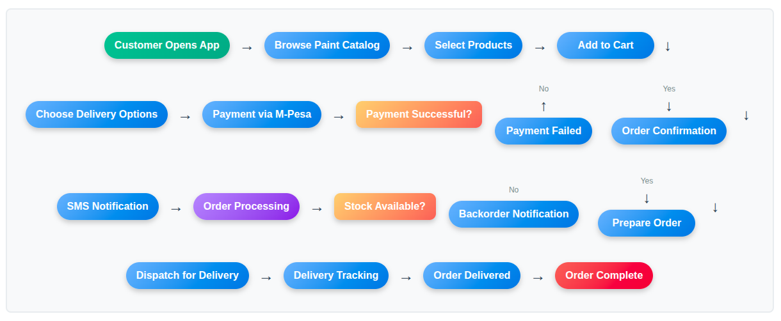

5.2 Service Booking Flow
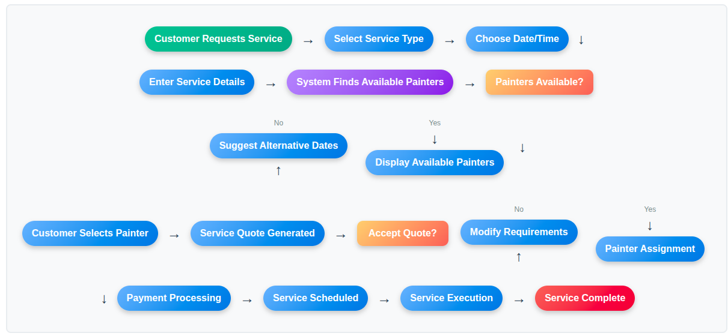

5.3 Painter Registration Flow
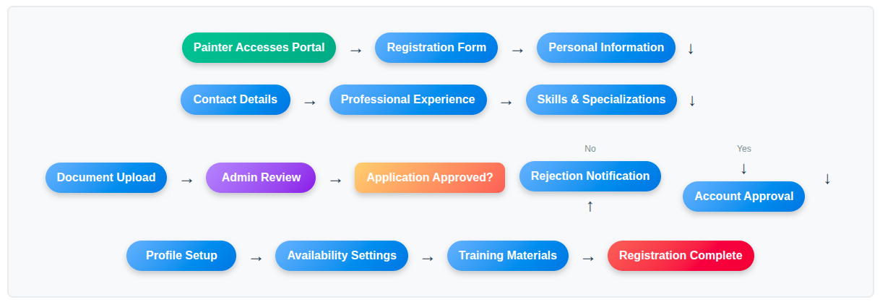

5.4 Admin Management Flow
Admin Dashboard → Monitor Orders → Manage Inventory →
Process Payments → Assign Painters → Generate Reports →
Customer Support → System Maintenance

6. Development Timeline

Phase 1: Planning & Design (2 weeks)
- Requirements analysis and documentation
- UI/UX design for mobile app and admin portal
- Database schema design
- API specification documentation
- Project setup and development environment

Phase 2: Backend Development (4 weeks)
- Database implementation and configuration
- RESTful API development
- Authentication and authorization system
- M-Pesa payment integration
- SMS notification system
- Testing and documentation

Phase 3: Frontend Development (4 weeks)
- Customer mobile app development
- Admin portal development
- API integration and testing
- UI/UX implementation
- Cross-platform compatibility testing

Phase 4: Integration & Testing (1 week)
- System integration testing
- Security testing and vulnerability assessment
- Performance optimization
- User acceptance testing
- Bug fixes and improvements

Phase 5: Deployment & Launch (1 week)
- Production environment setup
- App store submission
- Admin portal deployment
- User training and documentation
- Go-live support

7. Budget Estimate

7.1 Development Costs
Component | Cost (KSH)
Backend Development (Go + MySQL) | 35,000
Customer Mobile App (Angular Ionic) | 35,000
Admin Portal (Angular) | 45,000
Third-party Integrations (Mpesa, Bulk SMS and Email) | 10,000
Testing & Quality Assurance | 0
Project Management | 0
Subtotal | 125,000

7.2 Infrastructure & Licensing (The customer to be responsible for renewal)
Component | Cost (KSH)
Cloud Hosting (Renewed Annually) | 14,000
App Store Fees (Paid once to google) | 3,250
SMS Sender ID (Paid Once) | 8,000
Subtotal | 25,250

7.3 System Maintenance Fee
To pay 20% of the total development cost per year after Go Live date. This will facilitate 24 hrs technical support. The customer can opt not to be supported.

8. Risk Assessment & Mitigation

8.1 Technical Risks
- Risk: Third-party API limitations or downtime
- Mitigation: Implement fallback mechanisms and error handling
- Risk: Security vulnerabilities
- Mitigation: Regular security audits and penetration testing

8.2 Business Risks
- Risk: Low user adoption
- Mitigation: Comprehensive marketing strategy and user incentives
- Risk: Painter onboarding challenges
- Mitigation: Streamlined registration process and attractive commission structure

9. Post-Launch Support

9.1 Maintenance & Updates
- Regular bug fixes and performance improvements
- Feature enhancements based on user feedback
- Security updates and patches
- Third-party integration maintenance

9.2 Support Services
- 24/7 technical support
- User training and onboarding
- System monitoring and maintenance
- Regular backup and disaster recovery

10. Conclusion
The HAJU Paints Solutions mobile app platform represents a significant opportunity to digitize and streamline the paint industry in Kenya. With a comprehensive feature set, robust technical architecture, and strategic implementation plan, this project will position HAJU Paints as a market leader in digital paint retail and services.

Prepared by: S. Ndegwa || Full Stack Software Developer || Tel: 0726159307
Date: July 12, 2025
Version: 1.0

